Employee and Organization Reports

This module of the EBS Pay Suite User Guide describes the process to generate employee and organizationreports. To access the Employee and Organization Reports window, click on the **HR Module**. Double-click on **Reports** and select **Employee and Organization Reports**. Figure 1 illustrates the screen for Employee and Organization Reports. It consists of the following 2 tabs:

* **Criteria** – displays the various fields that contain information for generating employee and organization reports.
* **View Report** – displays the employee and organization report.

Reports for various categories of employee and organization can be generated in the EBS Pay Suite. These categories are displayed in the left panel of **Employee and Organization Reports** window as illustrated in figure 1 and as listed below:

* Service list
* Anniversary List
* New hire Log
* Termination List
* Termination Reason Detail
* Termination Summary
* Employee Category Summary
* Employee Category Detail
* Organizational Report
* Census Report
* Employee Job and Pay Details

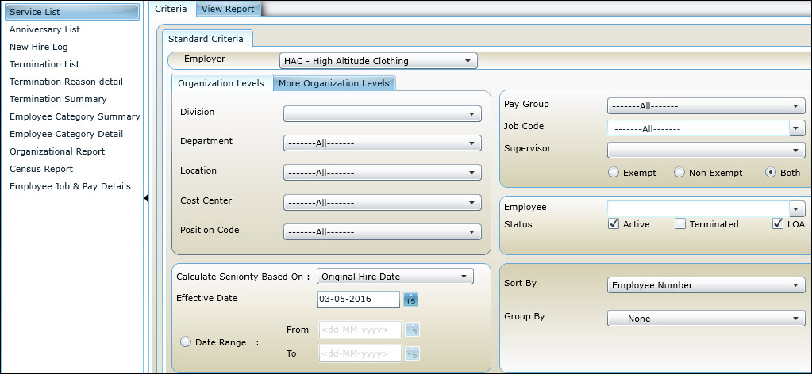Figure 1: Viewing the Criteria tab of Employee and Organization Reports

In the left panel, click on the required category/option to generate the report and do the following in the **Criteria** tab:

* Employer: Click on the drop-down menu and select the employer for whom you want to generate the report.
* In the **Organization Levels** tab, select **Division**, **Department**, **Location**, **Cost Center** and **Position Code** from the drop-down menu.

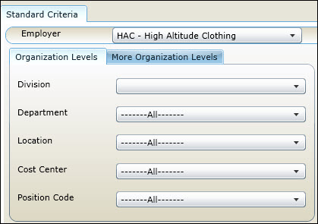  
Figure 2: Customizing fields in the Organization Levels tab

* In the **More Organization Levels** tab, select **Bonus Level**, **Bonus Rate**, **Account Number**, **Org Level** and **High Comp Approved** from the drop-down menu.

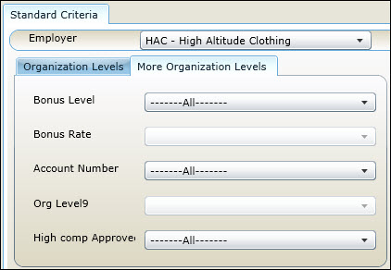  
Figure 3: Customizing fields in the More Organization Levels tab

* Calculate Seniority Based On: Assign a seniority level for the employee(s) by clicking on the applicable option in the drop-down menu.

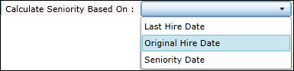  
Figure 4: Selecting seniority of the employee

* Effective Date or Date Range: You can select either effective date (seniority date as of) or a date range for calculating the seniority level. Click on the calendar icons to set the required date(s).

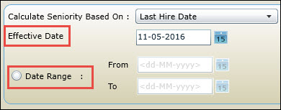

Figure 5: Setting the Date Range for Date Criteria

* Pay Group: Click and select a pay group from the drop-down menu.
* Job Code: Click and select a job code from the drop-down menu.
* Supervisor: Click and select a supervisor from the drop-down menu.
* Radio buttons: Click and select **Exempt**, **Non Exempt** or **Both**, based on the requirements.
* Employee: Click and select the name of an employee working for the chosen employer. You can also select all the employees.
* Status: Click on the checkbox(es) to select a status from the following: **Active**, **Terminated** and **LOA** .
* Sort By: Click and select an option to sort the report parameters, accordingly.

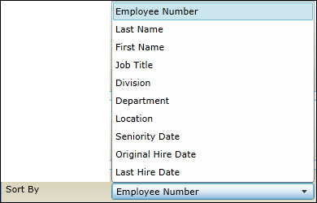  
Figure 6: Selecting the sorting option

* Group By: Click and select an option to group the report parameters.

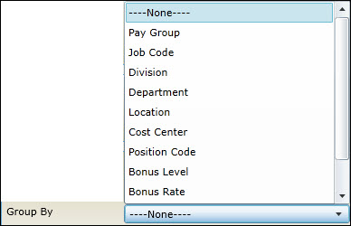  
Figure 7: Selecting the grouping option

* Preview: Finally, click on the **Preview** (preview_button.jpg) button to view the report. When you click the **Preview** button, the **View Report** tab is displayed.

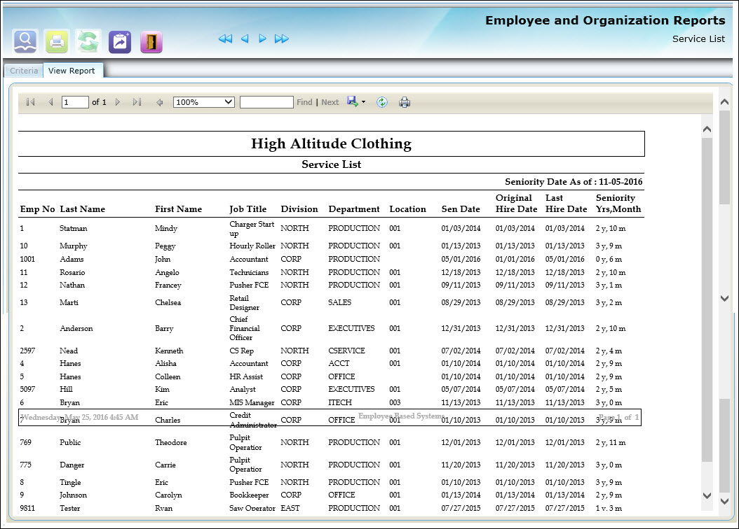Figure 8: Viewing Report

* Export Drop Down Menu: Click on the **Export Drop Down Menu** button in the report to export the report in formats such as excel, pdf and word.

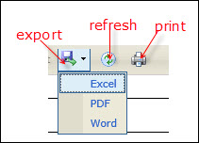  
Figure 9: Export, Refresh and Print buttons

* Refresh: Click on the **Refresh** button to refresh the report.
* Print: Click on the **Print** button to print the report.
* Buttons: The **Personal Information Reports** window consists of several useful buttons as illustrated in figure 10.

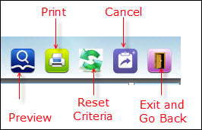  
Figure 10: Various buttons in the Personal Information Reports window

* + Preview: As explained earlier, click the **Preview** button to display the preview of the report.
  + Print: Click to print the data on the screen.
  + Reset Criteria: Click to reset the fields in the **Criteria** tab to default values.
  + Cancel: Click to cancel the report.
  + Exit and Go Back: Click to close the **Personal Information Reports** window.